Instructions for setting up CW Skimmer with Elecraft KX3, I/Q output and Asus Xonar U5 Sound Card
These instructions are for setting up CW Skimmer with an Elecraft KX3 radio, and using the KX3’s RX I/Q output into an ASUS XONAR U5 USB sound card. This gives a wider spectrum display than using the default 3 KHz wide speaker output audio signal.
CW Skimmer Setup
Quick Summary: (only showing KX3/RX I/Q setup details)
Radio: SoftRock-IF, CW Pitch=500, Audio IF=-500, Sample Rate=192 KHz
Audio: Soundcard Driver: MME, Signal I/O Device: 01 Line (4-ASUS XONAR U5), Channels: Left/Right = Q/I
Audio I/O Device: <Typically your PC’s sound card>, Shift Right Channel Data by: 0 samples
CAT: CAT Interface: Use Radio 1 -> Elecraft K3
Configure Button: RIG 1 -> Rig Type: Elecraft K3

CW Pitch: to whatever you normally prefer (try 500 Hz)
Audio IF: = - CW pitch (try -500)

CW Skimmer Setup Screens

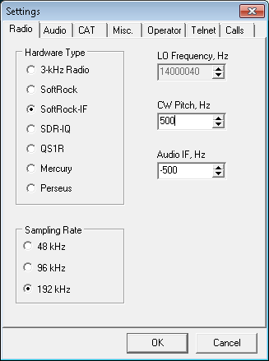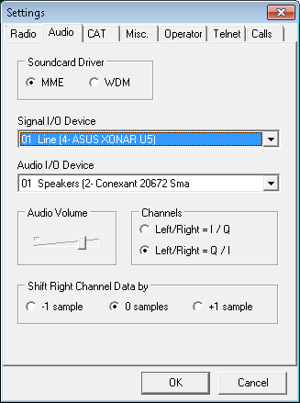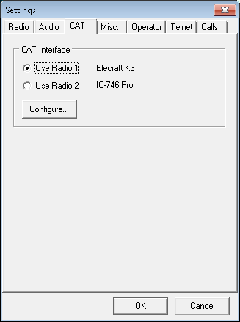
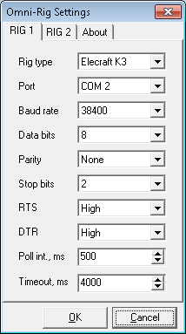
You will also need to set CW Skimmer’s CAT to KX3 for the appropriate com port. When you get Audio IF set correctly, the frequency readout in the box at the top of skimmer will read your radio's frequency and the little green indicator will be right on the signal you want to read.
ASUS XONAR U5 Setup
The ASUS U5 USB sound card needs to be setup using the ASUS utility Sonic Studio. Set the Input Device to LINE setting (not Microphone), in the Audio Config select Stereo, and Audio Format to 192 kHz, 24 Bits. Set the Record volume to maximum (100%). Do not enable any of the Audio Enhancement features. See screen shot below:
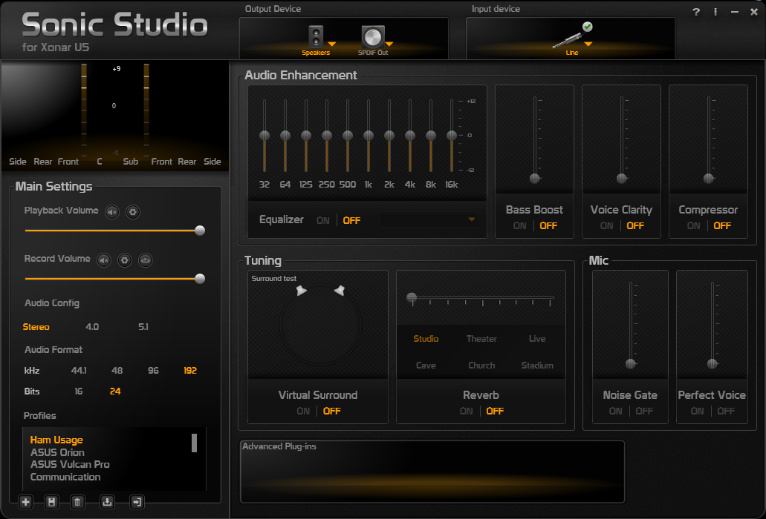
KX3 Setup
Enable the KX3’s RX I/O output via the menu item RX I/Q = On.
Note: it appears that the CW decoing on the KX3 works better when using a CW pitch set to 500 hz. You can try other CW pitch settings, but ensure that you change the CW Skimmer’s setup to match.
Cabling Setup
Connect the 2.5 mm cable from the KX3’s RX I/O port, to the ASUS U5 sound card’s 3.5mm Microphone input jack. Connect the USB cable to your PCs USB port. Ensure you have loaded the ASUS U5 drivers first.
This CW Skimmer setup was tested by Lane, VE7IHL. I am not a CW expert, so any errors, please let me know!

